Why not use near field probes to measure my emissions?

This is a question oft repeated by those trying to find a low cost method for judging compliance of their products. Most EMC test requirements for emissions are based on measurements of the RF field at a distance of 10m from the product. At this distance all sorts of ‘difficult’ factors become significant, such as background (ambient) signals, test site reflections, antenna calibration, ground plane and antenna height.
At first sight near field probes avoid these factors. It seems logical to assume that they provide an output proportional to the RF field strength radiated from a source… therefore it’s logical to assume that this is a good measure of the radiation ‘at a distance’. They certainly avoid the ‘ambient’ issue as near field probes (NFP) are relatively insensitive to far field radiation.
However, not only are the outputs from NFPs not proportional to the RF field at 10m, they can actually give entirely the opposite result to that intended.
To understand why this is so, we could (and should!) consult one of the many text books which are full of maths and Maxwell’s equations… but personally I find all this theory quite incomprehensible….. and so to offer an insight as to exactly how this RF stuff is created and works, I try to reduce difficult stuff to ‘pretty pictures’. So what follows is my own interpretation of what is happening. I do not pretend that it is rigorous or even correct, but it works for me and seems to explain other factors which otherwise seem entirely arbitrary.
To start at the beginning….. what is the origin of this stuff called ‘Electro-magnetic radiation’…….
Imagine a very simple circuit, as shown in fig 1.
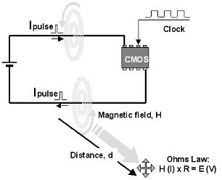
We have a battery supplying a CMOS chip. This is being clocked at (say) 16MHz.
When CMOS is dormant, it draws practically zero current, but at each clock edge, transistors change state and a small pulse of current flows round the supply circuit. Current in a conductor causes a magnetic field to be created around that conductor (we know that because this is how electric motors work). This magnetic field, which we call H, is proportional to the current flow. As soon as this small current pulse has passed, some of this magnetic energy decays back into the conductor in such a way that it opposes the next current pulse. In other words, the impedance presented to the next current pulse flowing down the conductor is increased. Here is the explanation of ‘self inductance’, the characteristic of any wire to become more ‘resistive’ as frequency is increased.
Fig 1. The classic source
That part of the magnetic energy that has not decayed back into the conductor continues to radiate away into space. We can think of this energy as equivalent to current (after all, it was current that created it), flowing through a conductor called ‘free space’. Free space has an impedance (someone actually measured it!), and its value is 377ohm. So now we have a current (H) flowing down a conductor with an impedance (resistance) of 377ohm. Ohms Law (V = I/R) now applies. There must be a voltage drop (E) equal to 377 x Current flowing (H). If the source was due entirely to current, the voltage at the source is zero and therefore the source impedance must also be zero (Ohms Law again). But at distance d, we do have a voltage component (E) and a current component (H) related by Ohms Law. This is our Electro-Magnetic Field.
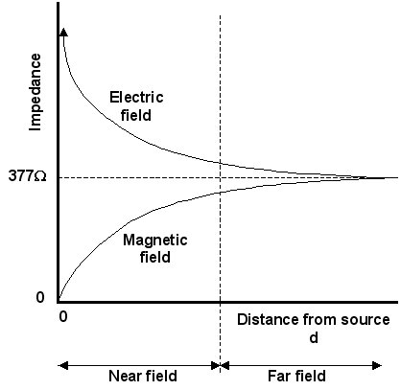
We can plot field impedance vs distance from the source. See fig 2. The magnetic field starts from the origin with zero impedance, but gradually converts to a wave impedance of 377ohm as we move away from the source. The diagram also shows the corresponding effect due to an electric field source. These are not as common as current sources, but could be envisaged as shown in fig 3. Here we have an open circuit situation, so current flow is clearly not a factor, but voltage can be high… hence a high impedance characteristic.
Fig 2. Field Impedence
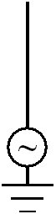
Now, antennas are generally either E field sensors, or H field sensors. The classic dipoles and log periodics are sensitive to E field, not H field. If they are used in the far field, either type of sensor will give a true reading because the E and H fields are related by the 377ohm factor. If however we try to use an EMC antenna (which is sensitive to only E field) in the near field, and the source is magnetic, our E field sensor will not ‘see’ the emissions and you will have incorrect results. This is why the EMC standards specify a minimum antenna distance. If you read the small print, it states a minimum of 3metres.
The transition from near field to far field is clearly not clear cut. It is dependant on frequency. Different sources quote different distances, between one third of a wavelength, up to one tenth of a wavelength. Note that the lowest frequency quoted in EMC radiated standards is 30MHz**. At this frequency the wavelength is 10m, so one third of this is around 3m, hence the instruction in the standards that the closest you should position the antenna to the product is 3m.
Fig 3.
E field source
** This prompts the question… why do the standards switch from conducted measurements to radiated measurements at 30MHz? It all stems from the fact that the impedance of a conductor increases with frequency. At dc, the impedance (resistance) of a length of wire is milliohms. As the frequency of a signal increases, this impedance rises. It so happens that at around 30MHz, the impedance of a typical wire is around 377ohm. Energy is lazy stuff and always takes the easiest route, so if you try to push energy down a wire at a frequency above 30MHz, then as far as this energy is concerned, free space appears as a lower impedance than the wire, so it takes the easiest route and radiates away!

The strength of emissions that have reached an antenna at a distance from the source are dependent on several factors…
- The strength of the source.
- The radiating mechanism.
- The effect of any screening.
- The effect of filtering.
- The characteristics of the local environment.

If for pre-compliance purposes we cannot control the environment, and we use screening and filtering as potential mitigating techniques, then we are left with the first two factors. Of these, the ‘radiating mechanism’ (which in other words is the Aerial) is the dominant factor. Consider a taxi firm which has a radio transmitter in the back office with which to communicate with its fleet. The transmitter may be able to generate many watts of RF power, but if the aerial is disconnected, it will not be able to talk to a car even just round the corner. This makes it obvious that it is the aerial which radiates emissions, not the source. Near field probes are great for detecting the location and frequency of sources, but they give little information about the efficiency of the radiating mechanism, the aerial. So we can have a situation (and very frequently do) where the near field probe produces a really strong response from a source, but when that frequency is measured at 3 or 10m, the emissions are well below the limits. On the other hand, a source may appear quite feeble with the near field probe, but the emissions are well over the limits. The former did not have any effective antenna, but the latter had (by chance) a perfect antenna.
So now we have established why you cannot measure emissions close-up, but we still need to consider what near field probes can and cannot do. There are two types of probe, because as we have seen, there are two types of near field, the electric (E) field and the magnetic (H) field. The magnetic probe takes the form of a small loop antenna which will respond to any magnetic flux coupling though the loop. The electric field probe is in essence a small monopole antenna. They are normally supplied in pairs and can be either passive or active. The active type have a broadband pre-amplifier built into the probe and as a result offer greater sensitivity and smaller tip size, better for accurate probing.

Consider a length of wire, open circuit at one end and being driven by an oscillator at the other. Fig 4 shows the instantaneous current distribution along the wire. At the driven end it will be at a maximum, but at the open circuit end it must be zero. The current distribution looks like one quarter of a sine wave, and indeed this shows the system in resonance. When wire has a length equal to one quarter the wavelength of the driving frequency the current peaks sharply and we have a tuned antenna. If the incoming frequency has components that happen to coincide with this tuned frequency, these components will be radiated.

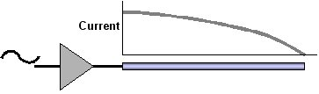
Fig 4. Cable resonance

Fig 5 shows a classic situation. We have our 16MHz clock source and this exhibits a full set of harmonics, gradually reducing in level with frequency. See the top plot. This is what our near field probes will see.
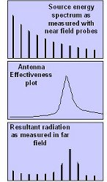
This signal is coupled to a wire that is 60cm long. It has a characteristic as shown in the middle plot. This will be resonant at a wavelength of 2.4m (4 x 60cm) which is 125MHz, so the 8th harmonic (128MHz) of the 16MHz source will be strongly radiated, even though this is a relatively small component of the original source. See the lower plot.
In fact, assessing any product in terms of its physical size and the length of any cables connected to it can sometimes give you a feel for what may be problem frequencies. Products fitted with a 1.5m mains lead can be a problem at 50MHz, and a golf trolley with a 50cm cable between the control panel near the handle and the motor at the wheels had an issue at 150MHz.
All this shows that it is the ‘accidental’ antenna that dominates the emission spectrum, and that the near field probes can give quite the wrong impression.
However, all is not lost, the probes do have several useful purposes.
- They can be used as sniffers to detect what frequencies are present in a product. Knowing which frequencies to look for is a great help when measuring emissions on an OATS…

Fig 5
Effect of the aerial
- Once a ‘problem’ is identified, the near field probe can help to track down the source. Active probes are good in this respect as they have high sensitivity and small probe tips.
- Probes can help with relative measurements if used with care and have a ‘proper’ EMC result to act as a reference.. For repeatability, the probes must always be placed in exactly the same position relative to the product during each check.
- They can be used as a QC tool to ensure that products off the ‘production line’ are consistent in terms of EMC characteristics, thus helping to fulfil the the ‘due diligence’ requirements of the EMC Directive to ensure that volume production is regularly monitored.

For details of active and passive near field probes, see….
http://www.laplace.co.uk/product/18/
http://www.laplace.co.uk/product/17/

David Mawdsley
Laplace Instruments Ltd

